Intelligent Admissions: The Future of University Decision Making with Machine Learning

Submitted by

V.CHANDRAMOHAN

CHAPTER 1

1.1 OVERVIEW

The project (Intelligent Admission: The future of university decision making with machine learning) to build a machine learning model that can predict In recent years, the use of machine learning in the admissions process for universities has become an increasingly popular topic. With the vast amounts of data that universities collect on applicants, machine learning algorithms have the potential to analyse this data and make more informed decisions about which students to admit. This approach, known as intelligent admissions, has the potential to improve the fairness, efficiency, and effectiveness of the admissions process.

By using machine learning algorithms, universities can identify patterns and trends in data that might not be immediately apparent to human admissions officers. This can help to eliminate biases that might exist in the current admissions process and allow universities to consider a wider range of factors when making decisions about which applicants to admit.

1.2 PURPOSE

The purpose of this project is to develop a machine learning model the purpose of the "Intelligent Admissions: The Future of University Decision Making with Machine Learning" project is to explore thepotential benefits of using machine learning algorithms in the admissions process for universities. The project aims to build a machine learning model that can analyze the vast amounts of data collected by universities on applicants and make more informed decisions about which students to admit.

The project seeks to address some of the limitations of the current admissions process by eliminating biases that might exist and allowing universities to consider a wider range of factors when making decisions. about admissions. Additionally, the project aims to improve the efficiency and effectiveness of the admissions process by automating certain aspects of the process, reducing the time and resources needed to make admissions decisions.

Result 1

* Import needed tools
* All needed tools added successfully

Result 2

<class 'pandas.core.frame.DataFrame'>

RangeIndex: 400 entries, 0 to 399

Data columns (total 9 columns):

# Column Non-Null Count Dtype

--- ------ -------------- -----

0 Serial No. 400 non-null int64

1 GRE Score 400 non-null int64

2 TOEFL Score 400 non-null int64

3 University Rating 400 non-null int64

4 SOP 400 non-null float64

5 LOR 400 non-null float64

6 CGPA 400 non-null float64

7 Research 400 non-null int64

8 Chance of Admit 400 non-null float64

dtypes: float64(4), int64(5)

memory usage: 28.2 KB

Result 3

Serial No. False

GRE Score False

TOEFL Score False

University Rating False

SOP False

LOR False

CGPA False

Research False

Chance of Admit False

dtype: bool

Result 4

<class 'pandas.core.frame.DataFrame'>

RangeIndex: 400 entries, 0 to 399

Data columns (total 9 columns):

# Column Non-Null Count Dtype

--- ------ -------------- -----

0 Serial No. 400 non-null int64

1 GRE Score 400 non-null int64

2 TOEFL Score 400 non-null int64

3 University Rating 400 non-null int64

4 SOP 400 non-null float64

5 LOR 400 non-null float64

6 CGPA 400 non-null float64

7 Research 400 non-null int64

8 Chance of Admit 400 non-null float64

dtypes: float64(4), int64(5)

memory usage: 28.2 KB

Result 5

|  | **Serial No.** | **GRE Score** | **TOEFL Score** | **University Rating** | **SOP** | **LOR** | **CGPA** | **Research** | **Chance of Admit** |
| --- | --- | --- | --- | --- | --- | --- | --- | --- | --- |
| **count** | 400.000000 | 400.000000 | 400.000000 | 400.000000 | 400.000000 | 400.000000 | 400.000000 | 400.000000 | 400.000000 |
| **mean** | 200.500000 | 316.807500 | 107.410000 | 3.087500 | 3.400000 | 3.452500 | 8.598925 | 0.547500 | 0.724350 |
| **std** | 115.614301 | 11.473646 | 6.069514 | 1.143728 | 1.006869 | 0.898478 | 0.596317 | 0.498362 | 0.142609 |
| **min** | 1.000000 | 290.000000 | 92.000000 | 1.000000 | 1.000000 | 1.000000 | 6.800000 | 0.000000 | 0.340000 |
| **25%** | 100.750000 | 308.000000 | 103.000000 | 2.000000 | 2.500000 | 3.000000 | 8.170000 | 0.000000 | 0.640000 |
| **50%** | 200.500000 | 317.000000 | 107.000000 | 3.000000 | 3.500000 | 3.500000 | 8.610000 | 1.000000 | 0.730000 |
| **75%** | 300.250000 | 325.000000 | 112.000000 | 4.000000 | 4.000000 | 4.000000 | 9.062500 | 1.000000 | 0.830000 |
| **max** | 400.000000 | 340.000000 | 120.000000 | 5.000000 | 5.000000 | 5.000000 | 9.920000 | 1.000000 | 0.970000 |

Result 6

<Axes: xlabel='GRE Score', ylabel='Density'>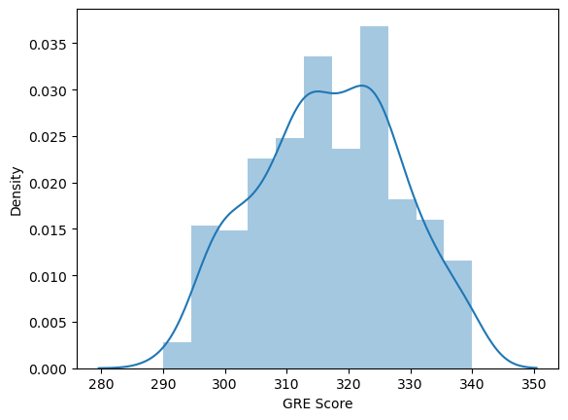

Result 7

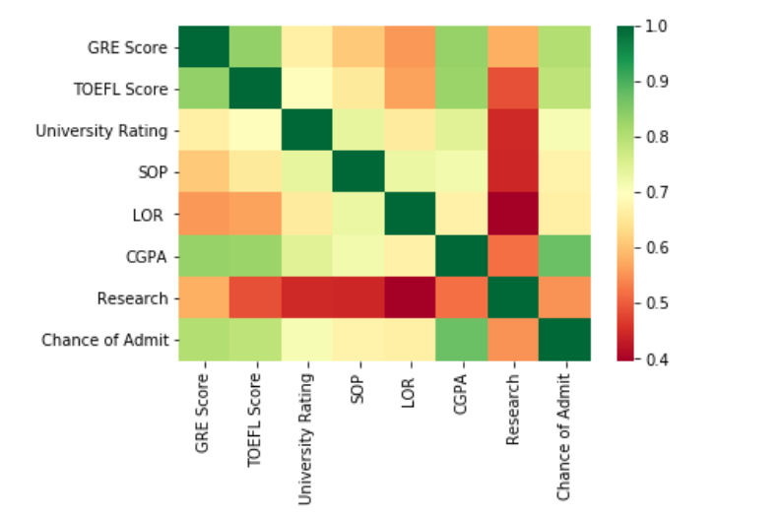

Result 8

<seaborn.axisgrid.PairGrid at 0x1394b9b94b0>

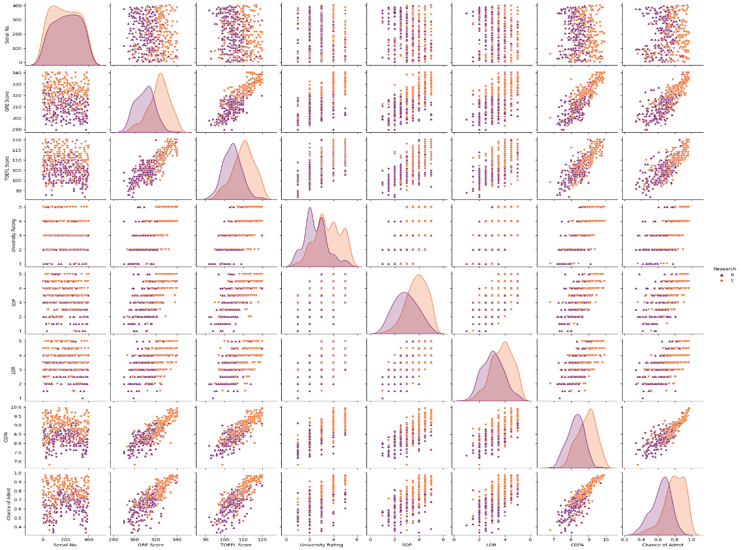

Result 9

<Axes: xlabel='University Rating', ylabel='CGPA'>

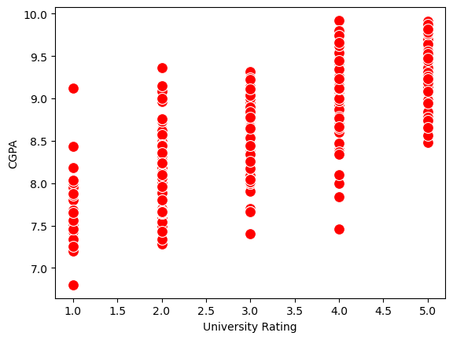

Result10

<class 'pandas.core.frame.DataFrame'>

RangeIndex: 400 entries, 0 to 399

Data columns (total 9 columns):

# Column Non-Null Count Dtype

--- ------ -------------- -----

0 Serial No. 400 non-null int64

1 GRE Score 400 non-null int64

2 TOEFL Score 400 non-null int64

3 University Rating 400 non-null int64

4 SOP 400 non-null float64

5 LOR 400 non-null float64

6 CGPA 400 non-null float64

7 Research 400 non-null int64

8 Chance of Admit 400 non-null float64

dtypes: float64(4), int64(5)

memory usage: 28.2 KB

Result 11

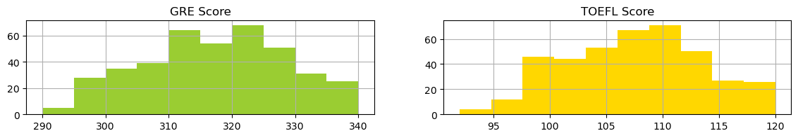

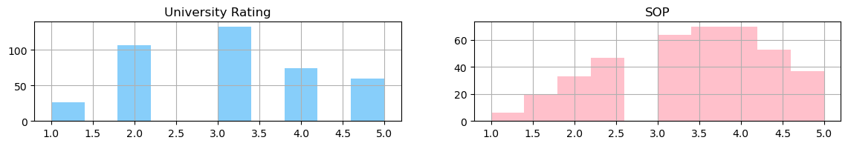

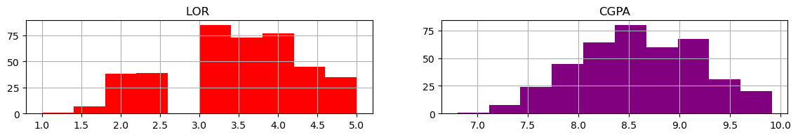

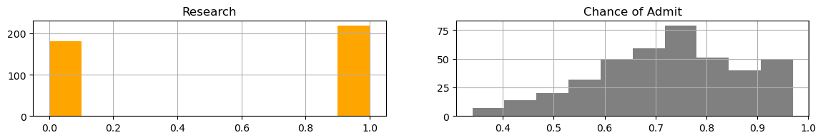

Result 12

array([[ 1. , 337. , 118. , ..., 4.5 , 4.5 , 9.65],

[ 2. , 324. , 107. , ..., 4. , 4.5 , 8.87],

[ 3. , 316. , 104. , ..., 3. , 3.5 , 8. ],

...,

[398. , 330. , 116. , ..., 5. , 4.5 , 9.45],

[399. , 312. , 103. , ..., 3.5 , 4. , 8.78],

[400. , 333. , 117. , ..., 5. , 4. , 9.66]])

Result13

array([False, True, True, True, True, True, True, True, True,

True, True, True, True, True, True, True, True, True,

False, True, True, True, True, True, True, True, True,

True, True, True, True, True, False, True, True, False,

True, False, True, True, True, True, True, True, True,

True, True, True, True, True, True, True, True, True,

True, True, True, True, True, True, True, True, True,

True, True, True, True, True, True, True, True, True,

True, True, True, True, True, True, True, True, True,

True, False, True, True, True, True, True, True, True,

True, True, True, True, True, True, True, True, True,

True, True, True, True, True, True, True, True, True,

True, True, True, True, True, True, True, True, True,

True, True, True])

Result 14

array([[0., 0.94, 0.92857143, ..., 0.875, 0.875, 0.91346154],

[0.00250627, 0.68 , 0.53571429, ..., 0.75 , 0.875, 0.66346154],

[0.00501253, 0.52 , 0.42857143, ..., 0.5 , 0.625 ,0.38461538],

...,[0.99498747, 0.8 , 0.85714286, ..., 1., 0.875, 0.84935897],

[0.99749373, 0.44 , 0.39285714, ..., 0.625 , 0.75 ,0.63461538],

[1. , 0.86 , 0.89285714, ..., 1. , 0.75 ,0.91666667]])

Result 15

Model: "sequential"

_________________________________________________________________

Layer (type) Output Shape Param #

=================================================================

dense (Dense) (None, 7) 56

dense_1 (Dense) (None, 7) 56

dense_2 (Dense) (None, 1) 8

=================================================================

Total params: 120

Trainable params: 120

Non-trainable params: 0

Result 16

Epoch 1/100

14/14 [==============================] - 3s 14ms/step - loss: 14.1579 - accuracy: 0.0821

Epoch 2/100

14/14 [==============================] - 0s 11ms/step - loss: 14.1579 - accuracy: 0.0821

Epoch 3/100

14/14 [==============================] - 0s 9ms/step - loss: 14.1579 - accuracy: 0.0821

Epoch 4/100

14/14 [==============================] - 0s 12ms/step - loss: 14.1579 - accuracy: 0.0821

Epoch 5/100

14/14 [==============================] - 0s 10ms/step - loss: 14.1579 - accuracy: 0.0821

Epoch 6/100

14/14 [==============================] - 0s 11ms/step - loss: 14.1579 - accuracy: 0.0821

Epoch 7/100

14/14 [==============================] - 0s 10ms/step - loss: 14.1579 - accuracy: 0.0821

Epoch 8/100

14/14 [==============================] - 0s 10ms/step - loss: 14.1579 - accuracy: 0.0821

Epoch 9/100

14/14 [==============================] - 0s 10ms/step - loss: 14.1579 - accuracy: 0.0821

Result 17

9/9 [==============================] - 1s 6ms/step

[[ -98.857574]

[-107.67336 ]

[ -94.33377 ]

[ -79.77212 ]

[ -71.00769 ]

[ -72.63707 ]

[-113.770065]

[ -76.36096 ]

[-104.20984 ]

[ -95.82141 ]

[ -74.685486]

[ -92.32373 ]

[-105.89253 ]

[ -72.50631 ]

[-112.265015]

[-118.16605 ]

Result 18

Accuracy score: 88.333333

Recall score: 96.296296

ROC score: 56.481481

[[ 2 10]

[ 4 104]]

Result 19

CLASSIFICATION REPORT

precision recall f1-score support

False 0.33 0.17 0.22 12

True 0.91 0.96 0.94 108

accuracy 0.88 120

macro avg 0.62 0.56 0.58 120

weighted avg 0.85 0.88 0.87 120